COSC 31103
Web & Internet Technologies Practical
Tutorial 06

PS/2021/121
S.D.HENDAWITHARANA

HOME.HTML
<html>
<head>

<title>Pet Care - Home</title>
<link rel="stylesheet" href="style.css">
</head>
<body>
<header>
<nav>
<h1>PET CARE</h1>
<ul>
<li><a href="home.html">HOME</a></li>
<li><a href="about.html">ABOUT</a></li>
<li><a href="review.html">REVIEWS</a></li>
<li><a href="contact.html">CONTACT</a></li>
</ul>
</nav>
</header>
<section class="hero">
<div class="overlay">
<h2>HAPPY AND COMFORTABLE PARENTING!</h2>
<p>Hey Pet Parents! Welcome to Pet Care. Shop on our website to avail
exciting offers...</p>

<a href="home.html" class="btn">GET STARTED</a>
</div>
</section>
<footer>
<div class="footer-content">
<div class="logo-section">
<img src="image06.jpg" alt="Pet Care Logo" />
<p>This site is functioning efficiently and serves as a platform for pet care
solutions and services across all pet lovers.</p>
</div>
<div class="info">
<h4>Have A Question</h4>
<ul>
<li>Services</li>
<li>Dog Hostel</li>
<li>About Us</li>
<li>Contact Us</li>
</ul>
</div>
<div class="address">
<h4>Information</h4>
<p>Pet Care (Pvt) Ltd, 1st Floor, Dalugama, Kelaniya</p>
<p>Telephone: 011 3000999</p>
<p>Email: info@petcare.com</p>
</div>

<div class="map">
<h4>Visit Us</h4>
<iframe src="https://maps.google.com/maps?q=Kelaniya&output=embed"
width="100%" height="100" style="border:0;" allowfullscreen=""></iframe>
</div>
</div>
<p class="copyright">© 2025 Pet Care. All rights reserved.</p>
</footer>
</body>
</html>
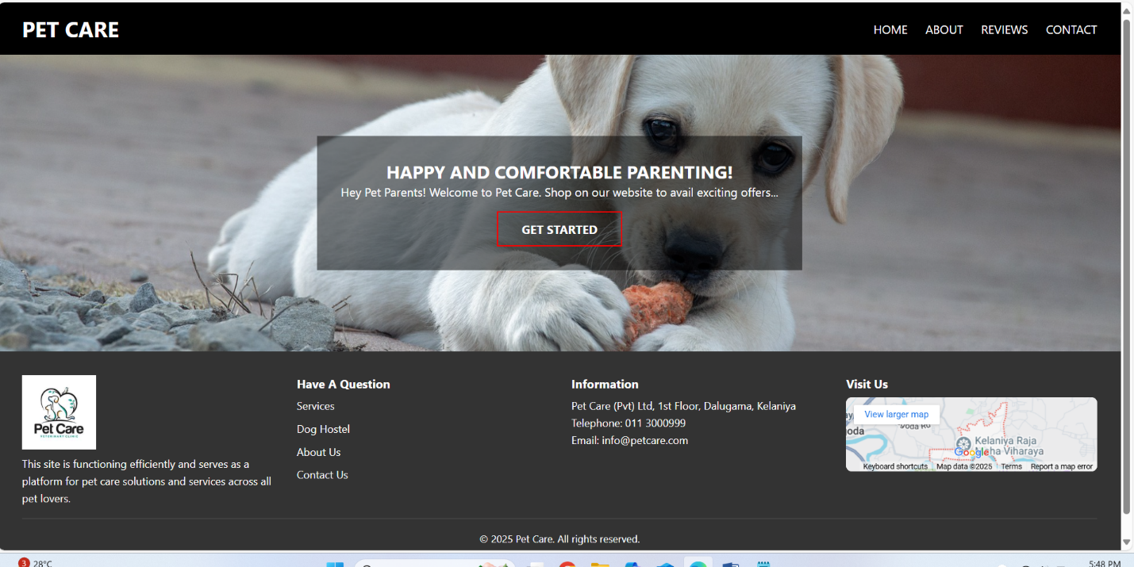
ABOUT.HTML
<html>
<head>

<title>Pet Care - About</title>
<link rel="stylesheet" href="style.css">
</head>
<body>
<header>
<nav>
<h1>PET CARE</h1>
<ul>
<li><a href="home.html">HOME</a></li>
<li><a href="about.html">ABOUT</a></li>
<li><a href="review.html">REVIEWS</a></li>
<li><a href="contact.html">CONTACT</a></li>
</ul>
</nav>
</header>
<section class="about">
<img src="image01.jpg" alt="Dog with Rose">
<div class="about-text">
<h2>ABOUT US</h2>

<p>Welcome to Pet Care Shop on our website to avail exciting offers
exclusively for youe pet friend.Earn points and get Coupans for additional
discounts.We deal in Dog Toys.Tasty Snacks,Collars,Leashes,Harness with latest
designs that you and your pet will fall in love with.Want to stay in touch?No
problem the page also features useful links to social media pages,as well as our
online shop. </p>
<div class="btn-group">
<a href="#">WORK</a>
<a href="review.html">REVIEW</a>
<a href="contact.html">CONTACT</a>
</div>
<div class="social-icons">
<a href="#"><img src="f.png"></a>
<a href="#"><img src="i.png"></a>
<a href="#"><img src="y.png"></a>
<a href="#"><img src="w.png"></a>
</div>
</div>
</section>
<footer>
<div class="footer-content">
<div class="logo-section">
<img src="image06.jpg" alt="Pet Care Logo" />
<p>This site is functioning efficiently and serves as a platform for pet care
solutions and services across all pet lovers.</p>
</div>

<div class="info">
<h4>Have A Question</h4>
<ul>
<li>Services</li>
<li>Dog Hostel</li>
<li>About Us</li>
<li>Contact Us</li>
</ul>
</div>
<div class="address">
<h4>Information</h4>
<p>Pet Care (Pvt) Ltd, 1st Floor, Dalugama, Kelaniya</p>
<p>Telephone: 011 3000999</p>
<p>Email: info@petcare.com</p>
</div>
<div class="map">
<h4>Visit Us</h4>
<iframe src="https://maps.google.com/maps?q=Kelaniya&output=embed"
width="100%" height="100" style="border:0;" allowfullscreen=""></iframe>
</div>
</div>
<p class="copyright">© 2025 Pet Care. All rights reserved.</p>
</footer>

</body>
</html>
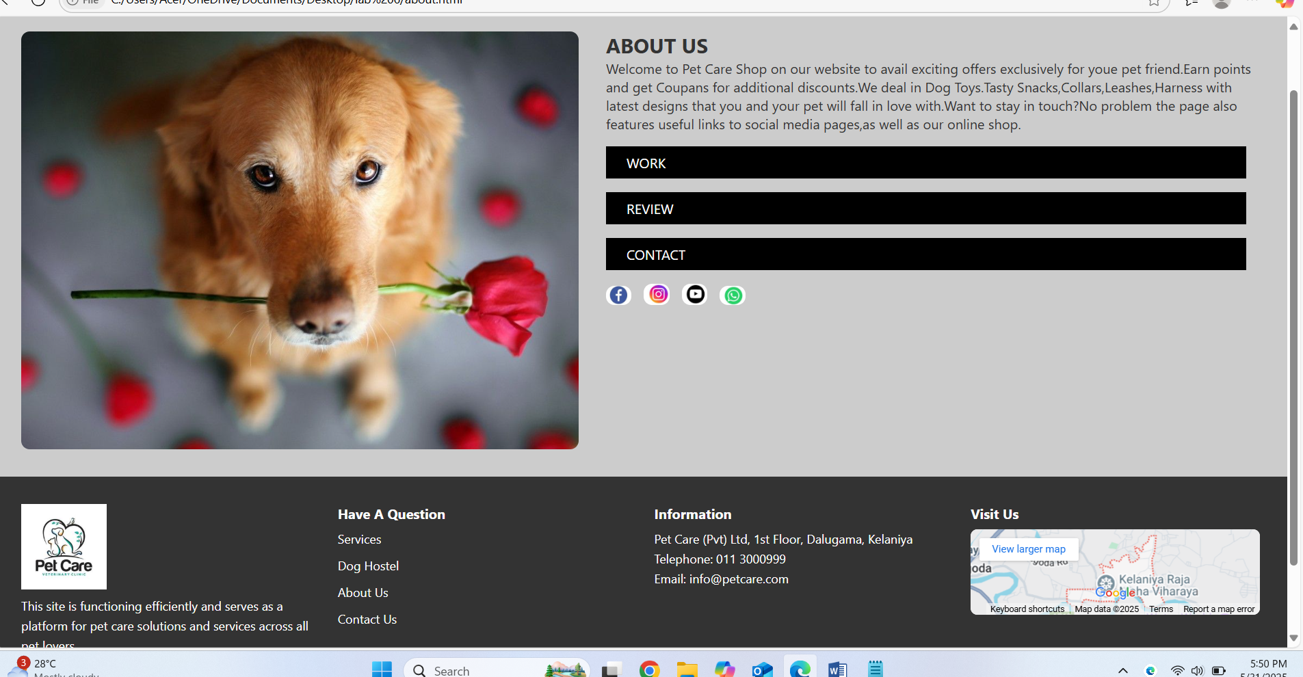

REVIEWS.HTML
<html>
<head>

<title>Customer Reviews - Pet Care</title>
<link rel="stylesheet" href="style.css"/>
</head>
<body>
<header>
<nav>
<img src="image05.jpg" width="50"alt="logo" class="logo-left"/>
<h1 align="center">PET CARE</h1>
<img src="image05.jpg" width="50" alt="logo" class="logo"/>

<ul>
<li><a href="home.html">HOME</a></li>
<li><a href="about.html">ABOUT</a></li>
<li><a href="review.html">REVIEWS</a></li>
<li><a href="contact.html">CONTACT</a></li>
</ul>
</nav>
</header>

<main>
<h2 class="section-title">CUSTOMERS</h2>
<div class="reviews">
<div class="review-card">
<h3>Quick Service</h3>

<p>"We placed a food order, and the delivery was super quick. They also
helped us choose a suitable shampoo for our dog. Thank you for the excellent
service!"</p>
<div class="reviewer">
<img src="image12.jpg" alt="Stephan Fernando" />
<p><strong>Stephan Fernando</strong>, Kelaniya</p>
</div>
</div>
<div class="review-card">
<h3>Comfortable Shopping</h3>
<p>"This service is excellent. It’s so easy to shop online. The items were
neatly packed and delivered to my doorstep. Love the experience!"</p>
<div class="reviewer">
<img src="image13.jpg" alt="Peter Almeda" />
<p><strong>Peter Almeda</strong>, Kadawatha</p>
</div>
</div>
<div class="review-card">
<h3>Best Discounts</h3>
<p>"I can't even express how happy I am about the discounts and coupons I
received. Great offers for every product and good quality!"</p>
<div class="reviewer">
<img src="image14.jpg" alt="Raveesha Perera" />
<p><strong>Raveesha Perera</strong>, Kiribathgoda</p>
</div>
</div>

</div>
</main>
<footer>
<div class="footer-content">
<div class="logo-section">
<img src="image06.jpg" alt="Pet Care Logo" />" alt="Pet Care Logo" />
<p>This site is functioning efficiently and serves as a platform for pet care
solutions and services across all pet lovers.</p>
</div>
<div class="info">
<h4>Have A Question</h4>
<ul>
<li>Services</li>
<li>Dog Hostel</li>
<li>About Us</li>
<li>Contact Us</li>
</ul>
</div>
<div class="address">
<h4>Information</h4>
<p>Pet Care (Pvt) Ltd, 1st Floor, Dalugama, Kelaniya</p>
<p>Telephone: 011 3000999</p>
<p>Email: info@petcare.com</p>
</div>
<div class="map">

<h4>Visit Us</h4>
<iframe src="https://maps.google.com/maps?q=Kelaniya&output=embed"
width="100%" height="100" style="border:0;" allowfullscreen=""></iframe>
</div>
</div>
<p class="copyright">© 2025 Pet Care. All rights reserved.</p>
</footer>
</body>
</html>
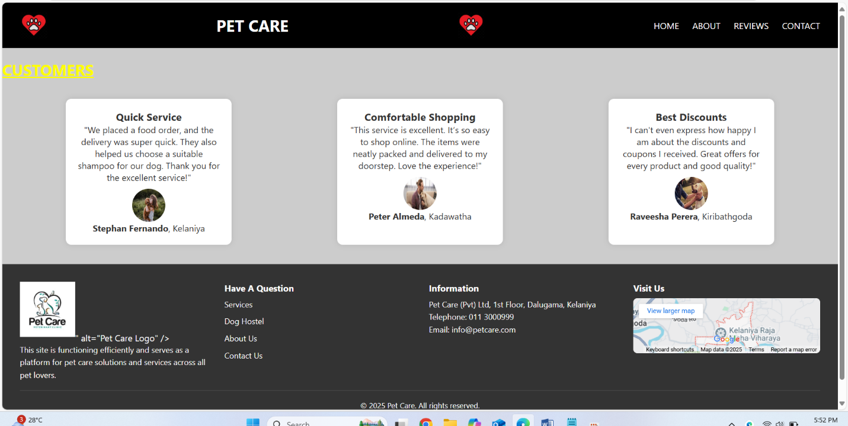

CONTACT.HTML
<html>
<head>

<title>Pet Care - Contact</title>
<link rel="stylesheet" href="style.css">
</head>
<body>
<header>
<nav>
<h1>PET CARE</h1>
<ul>
<li><a href="home.html">HOME</a></li>
<li><a href="about.html">ABOUT</a></li>
<li><a href="review.html">REVIEWS</a></li>
<li><a href="contact.html">CONTACT</a></li>
</ul>
</nav>
</header>
<section class="contact">
<h2>CONTACT US</h2>
<form>
<input type="text" placeholder="Name">

<input type="text" placeholder="Subject">
<input type="text" placeholder="Phone">
<input type="email" placeholder="Email">
<textarea placeholder="Message"></textarea><br>
<button type="submit">SUBMIT NOW</button>
</form>
</section>
<footer>
<div class="footer-content">
<div class="logo-section">
<img src="image06.jpg" alt="Pet Care Logo" />
<p>This site is functioning efficiently and serves as a platform for pet care
solutions and services across all pet lovers.</p>
</div>
<div class="info">
<h4>Have A Question</h4>
<ul>
<li>Services</li>
<li>Dog Hostel</li>
<li>About Us</li>
<li>Contact Us</li>
</ul>
</div>
<div class="address">
<h4>Information</h4>

<p>Pet Care (Pvt) Ltd, 1st Floor, Dalugama, Kelaniya</p>
<p>Telephone: 011 3000999</p>
<p>Email: info@petcare.com</p>
</div>
<div class="map">
<h4>Visit Us</h4>
<iframe src="https://maps.google.com/maps?q=Kelaniya&output=embed"
width="100%" height="100" style="border:0;" allowfullscreen=""></iframe>
</div>
</div>
<p class="copyright">© 2025 Pet Care. All rights reserved.</p>
</footer>
</body>
</html>
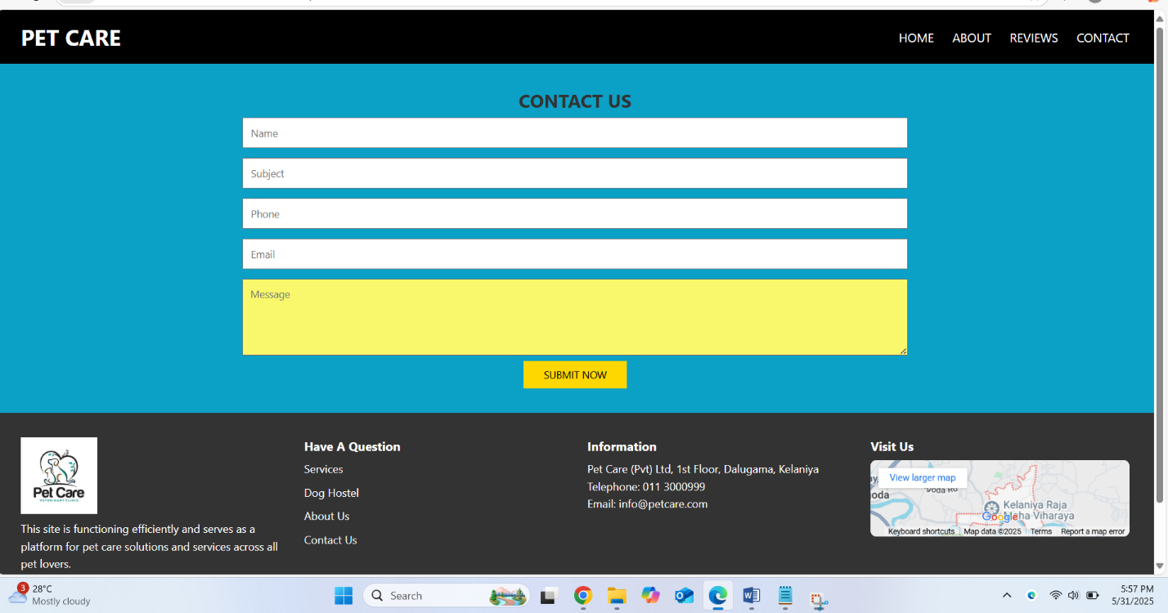

STYLE.CSS
* {
margin: 0;
padding: 0;
box-sizing: border-box;
font-family: 'Segoe UI', sans-serif;
}
body {
background: #fff;
color: #333;
}
header nav {
background: black;
color: white;
padding: 1em 2em;
display: flex;
justify-content: space-between;
align-items: center;
}
nav h1 {
font-size: 1.8em;
}
nav ul {
list-style: none;

display: flex;
gap: 1.5em;
}
nav a {
color: white;
text-decoration: none;
}
.hero {
background: url('image04.jpg') center/cover no-repeat;
height: 400px;
display: flex;
align-items: center;
justify-content: center;
}
.hero .overlay {
background: rgba(0, 0, 0, 0.5);
color: white;
text-align: center;
padding: 2em;
}
.btn {
display: inline-block;
margin-top: 1em;
padding: 0.7em 2em;

border: 2px solid red;
color: white;
text-decoration: none;
font-weight: bold;
}
.about {
display: flex;
padding: 2em;
gap: 2em;
}
.about img {
width: 45%;
border-radius: 10px;
}
.about-text {
flex: 1;
}
.btn-group a {
display:grid;
margin: 1em 1em 1em 0;
padding: 0.5em 1.5em;
background: black;
color: white;
text-decoration: none;

}
.social-icons img {
width: 30px;
margin-right: 10px;
}
.contact {
padding: 2em;
background: #0ba0c5;
text-align: center;
}
.contact input, .contact textarea {
width: 60%;
margin: 0.5em 0;
padding: 0.7em;
}
.contact textarea {
height: 100px;
background: #f9f86c;
}
.contact button {
background: gold;
padding: 0.7em 2em;
border: none;
cursor: pointer;

}

.reviews {
display: flex;
justify-content: space-around;
padding: 20px;
flex-wrap: wrap;
}
body {
margin: 0;
font-family: Arial, sans-serif;
background-color: #ccc; /* Light gray background */
}

/* Section title - "CUSTOMERS" */
.section-title {
text-align: left;
font-size: 28px;
margin-top: 20px;
color: yellow;
text-decoration: underline;
}

.review-card {
background-color: white;
border-radius: 10px;
box-shadow: 0px 0px 10px rgba(0,0,0,0.1);
width: 300px;
margin: 15px;
padding: 20px;
text-align: center;
}

.reviewer img {
width: 60px;
height: 60px;
border-radius: 50%;
margin-top: 10px;
}

footer {
background-color: #333;
color: white;
padding: 2rem;
}

.footer-content {
display: grid;
grid-template-columns: repeat(auto-fit, minmax(220px, 1fr));
gap: 2rem;
margin-bottom: 1rem;
}
footer h4 {
margin-bottom: 0.5rem;
}
footer p,
footer li {
font-size: 0.9rem;
line-height: 1.6;
}
footer ul {
list-style: none;
padding: 0;
}
footer ul li {
margin-bottom: 0.5rem;
}

footer img {

width: 100px;
margin-bottom: 0.5rem;
}

footer iframe {
border-radius: 8px;
}
footer .copyright {
text-align: center;
font-size: 0.85rem;
border-top: 1px solid #555;
padding-top: 1rem;
margin-top: 1rem;
}

